Thomas Ho
CS 6019 – MSD Project
August 27th, 2024
Professor Nabil Makarem
Capstone Proposal – ParPerks
Project Description:
For my project, I will be making a mobile app game called either ForeZone or ParPerks. This is a real-world golf game that awards perks when players physically enter a specific geo-fenced zone on a golf course. It is like a spin-off of Pokémon Go. These areas would include the course the tee box, clubhouse, driving range, practice putting greens, bunkers, water hazards, rough, or areas under trees. The app will track the player's real-time GPS locations and deliver randomized in-game perks/advantages. The user/player can walk or ride carts into these mapped areas.

To address real-world player dynamics, such as multiple players playing together. The mobile app game is designed to treat each player individually. Each player will log into the app with their customer username or gamertag. They will have the option to join or create a shared lobby with their friends or random players that they get paired up with on the course. This will ensure that each player will have different unique perks or bonuses from other players in that lobby.

The lobby system will also allow players to see other players' active perks, which will create a social and competitive element. Whether the player is walking or riding together on the course, each golfer's journey becomes uniquely interactive and engaging with others.
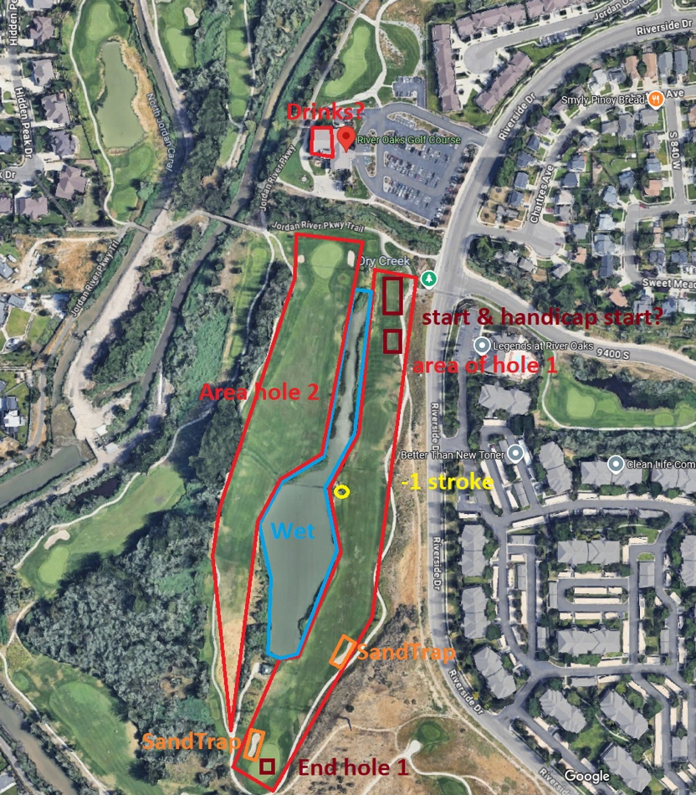
Examples Perks Based on GeoFenced Zones:
- Entering the clubhouse bar after completing 18th holes or on the turn at the 9th hole could earn the “Beverage perk”.
- Hitting areas such as “ParkingLot Clubhouse Course – Hole 1 ParkingLot” could unlock a perk, “Forgot something in the car, Extra Ball in Pocket”.
- Walking into a sand trap could unlock the “Sandy Boots Perk”.
- GPS signal in or near a water hazard could unlock the perk “Gone Swimming”.
- Walking into or under a tree zone area could unlock the perk “Lumberjack Hacking Away”.

This app will include:
- User authentication and session tracking.
- User profile, editing, ranking, statistics, information, etc.
- GPS tracking to detect their movement across the golf course zones.
- GeoFenced areas will trigger and deliver perks in the mapped golf course zones.
- Spinning wheel or something like a slot machine that will randomize a perk to be given out to that player.
- Game app lobby that includes more than 2+ players can see the spin of other players.
- Game app lobby will show player, perks, golf hole number, score (what kind of par hole it is and what they scored).

Tools and Skills Involved:
- Client (React Native + Expo)
  - Expo Location (expo-location) – foreground/background GPS
  - Expo Task Manager (expo-task-manager) – runs the background location task
  - React Native Maps (react-native-maps, Apple Maps provider) – renders the map and user pin.
  - Turf.js (@turf/turf, especially Boolean-point-in-polygon) – checks if the user’s GPS point is inside a GeoJSON polygon (tee box, bunker, water hazard, etc.)
- Backend & Database: Firebase Authentication
  - Supabase Authentication & Database

- GPS, GeoFencing APIs, OpenStreetMap, GeoJSON
Mock-ups – GUI (Figma)
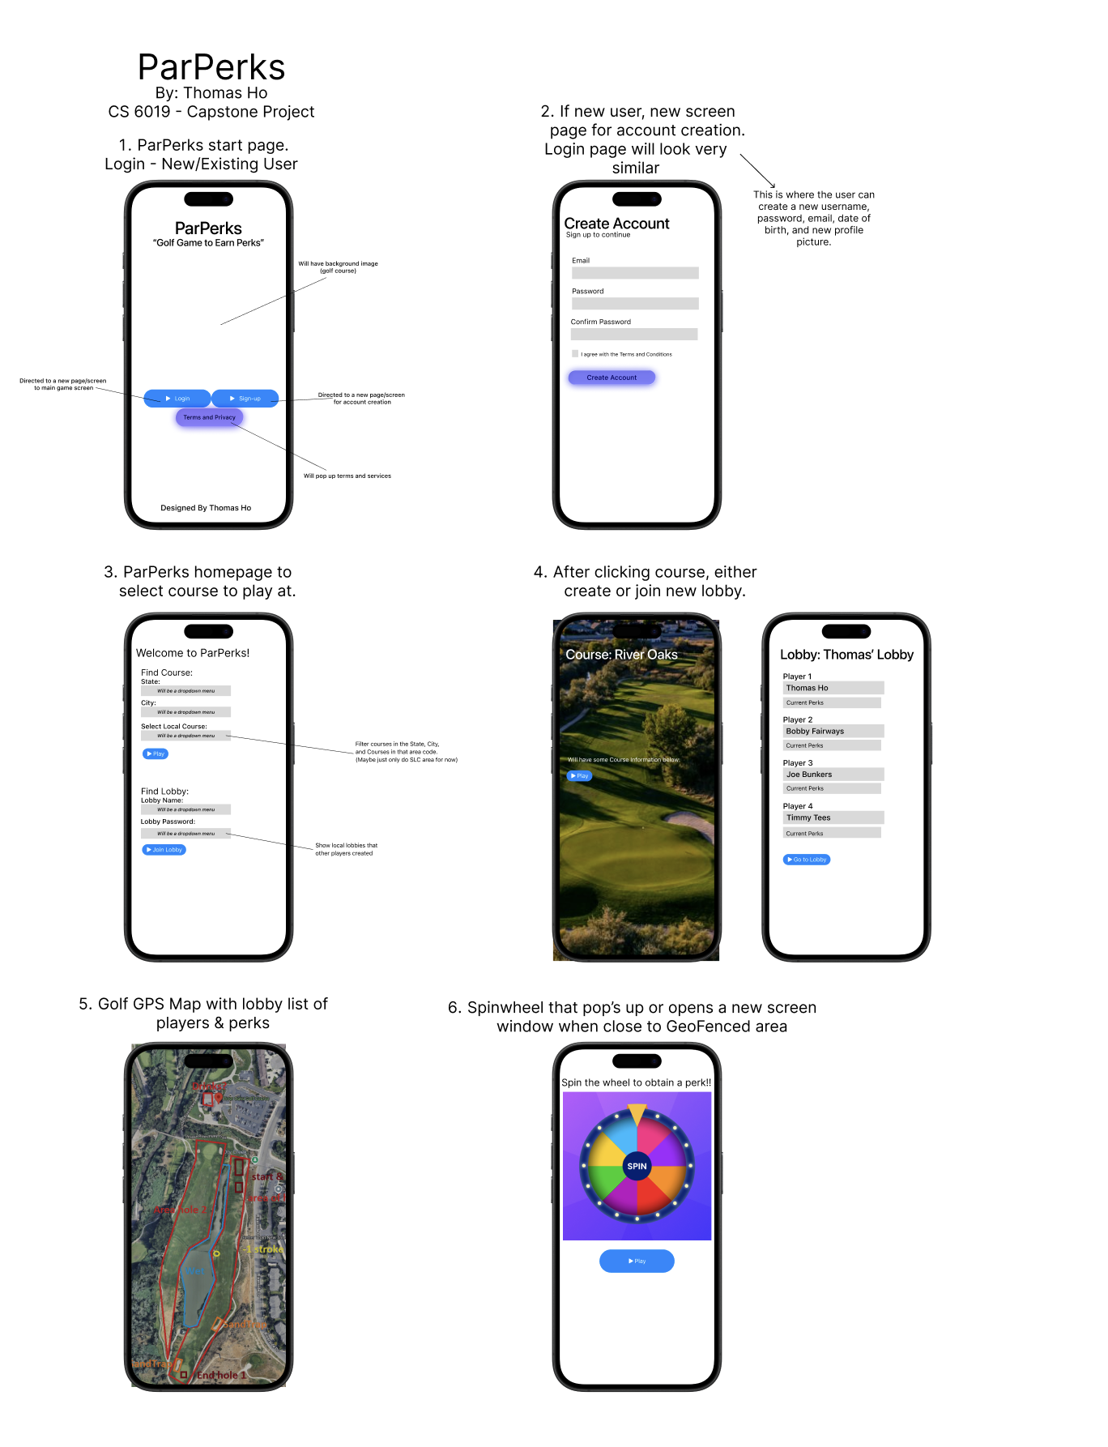

Timeline for completing the project
September 1st – September 7th
- Complete Figma design (UI)
- Begin outlining database schema (entities, relations, queries)
September 8th – September 14th
- Set up code base (repo, classes, file structure, build system)
- Connect app skeleton to mock data
September 15th – September 21st
- Implement authentication (login, signup, session management)
- Set up database (Firebase/Firestore or chosen Data Base)
September 22nd – September 28th
- Implement core gameplay/feature loop (e.g., geo location, golf perk tracking)
- Hook UI to live database reads/writes
September 29th – October 5th
- Build user profile system (progress, history, saved data)
- Add error handling & loading states
October 6th – October 12th
- Implement map/location features (GeoJSON, Turf.js, Mapbox integration)
- Hook UI to live database reads/writes
October 13th – October 19th
- Add secondary features (rewards, leaderboards, or notifications)
- Ensure GPS sharing works on device
October 20th – October 26th
- Conduct internal testing (unit tests, bug fixes, core functionality check)
- Optimize database queries and reduce load time
October 27th – November 2nd
- Conduct beta testing with peers (collect feedback)
- Adjust based on useability + bug reports
November 3rd – November 9th
- Finalize features
- Improve documentation (setup guide, API usage, code comments)
November 10th – November 16th
- Conduct final integration testing (full flow, edge cases, error handling)
- Start drafting Final Report
November 17th – November 23rd
- Submit Final Report
November 24th – November 30th
- Incorporate feedback from draft
- Prepare presentation slides & video demo
December 1st – December 7th
- Final Report, Presentation Video, and Review

SupaBase
user_profiles Table
Purpose: Stores additional information about your users beyond the basic authentication details.
- id: Unique identifier for each profile record
- user_id: Links the user in SupaBase’s built-in auth.user table
- username: Unique username for the user
- email: User’s email address (matches the one in auth.users)
- full_name: User’s full name
- avatar_url: URL to the user’s profile picture
- handicap: Golf handicap specific to the app
- created_at/ updated_at: Timestamps for record keeping

user_sessions Table
Purpose: Tracks user login sessions for analytics, security, or session management.
- id: Unique identifier for each session
- user_id: Links the user who created the session
- device_info: Information bout the device used to login
- ip_address: The IP address from which the user logged in
- created_at: When the session was created
- expires_at: When the session should expire

user_profile_view View
Purpose: Provides a combined view of data from both auth.users and user_profiles tables.

